Quantifying the Performance of Individual (Rising Star?) Players in a Team Competition

Methodology

In order to determine how individual features can be quantified, and as a test bed for other team-based human activities, we are going to analyze the performance of players in the Volleyball Nations League 2022 volleyball tournament. We will develop a network approach that provides a powerful quantification of the contributions of individual players and of overall team performance.

Eight matches (30 sets) of the quarter final round of the 2022 VNL (Men) will be analyzed.

Variable:

* Game actions:
  1. Type of serve (power jump serve, standing serve, jump floating serve)
  2. Serve efficacy (point, errors, attempts, total, efficiency)
  3. Setting efficacy (point, errors, attempts, total, efficiency)
  4. Attack efficacy (point, errors, attempts, total, efficiency)
  5. Block efficacy (point, errors, touches, total, efficiency)
  6. Reception efficacy (successful, errors, attempts, total, efficiency)
  7. Space Acronym: Playing Court (1, 2, 3, 4, 5, 6, 7, 8, 9), Free Zone (FZ), Serve Area (L, M, Y), As figure below.
  8. Type of action Acronym:

Serve: power jump serve-JS, standing serve-SS, jump floating serve-FS

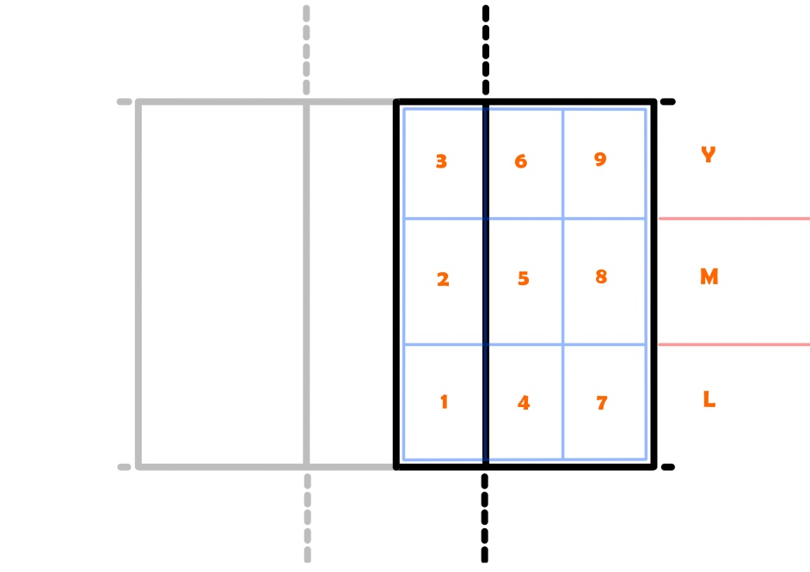Reception: R, Setting: G, Attack: A, Block: B, Dig: D, As figure below.

* Position:
  1. MB = Middle blocker
  2. S = Setter
  3. (L) / L = Libero
  4. OP = Opposite
  5. OH = Outside Hitter
* Individuals:

1. high-status members (Koster & Aven, 2018)
2. Captain
3. Rising Star (Bai & Bai, 2022)

* Outcome:

overall team performance (DV=winning rate)

References:

1. Bai, Z., & Bai, X. (2022). Towards Understanding the Analysis, Models, and Future Directions of Sports Social Networks. *Complexity*, *2022*.
2. Duch, J., Waitzman, J.S., & Nunes Amaral, L.A. (2010). Quantifying the performance of individual players in a team activity. PLoS One, 5, e10937.
3. Koster, J., & Aven, B. (2018). The effects of individual status and group performance on network ties among teammates in the National Basketball Association. PloS one, 13(4), e0196013.
4. Martins, J. B., Mesquita, I., Mendes, A., Santos, L., & Afonso, J. (2021). Inter-team variability in high-level women’s volleyball from the perspective of Social Network Analysis: an analysis in critical game scenarios. International Journal of Performance Analysis in Sport, 21(4), 564–578. https://doi.org/10.1080/24748668.2021.1924524